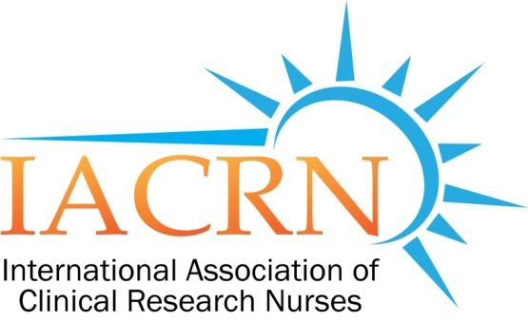

IACRN Research Committee Minutes
May 11, 2016
2016 |  |  | 2017
Jan 13 | May 11 | Sept 14 | Jan 11
Feb 10 | Jun 8 | Oct 12 & 26 | Feb 8
Mar 9 | Jul 13 | Nov 9 | Mar 8
Apr 13 | Aug 10 | Dec 14 | Apr 12
IACRN 8th Annual Conference,
October 24-26, 2016,
Wyndam Lake, Buena Vista, Florida.
Please see IACRN website for details

Members Present:
Cheryl Fisher - Chair | Carolynn Jones
Catherine Griffith - Facilitator | Kathy Grinke

Meeting convened at 3:35PM EST:
Cheryl Fisher, Committee Chair presiding

- Announcements:
  - Please check your credentials on the poster.
  - Almost final.

- Review of minutes for April 13, 2016: minutes approved as written. (CFisher/CTJ)

- Discussion related to Conference abstract submission process.
  - Members related frustrations and difficulties with abstract submission process. Catherine/Carolynn will bring these issues back to the conference planning committee

- Workforce-Domains: Cheryl
    - Proposal near completion. Meeting with NIH ISRC (Intramural Scientific Review Committee for Clinical Center Nursing Dept) for comments and feedback has been reschedulued to June 27, 2:00 to 3:30pm; Cheryl will do the presentation and then ask for comments and feedback; Committee members are invited to attend via teleconference. Requesting feedback on sample size needed (power);
    - Next step after consultation with ISRC, is to consult with Gordon Hill for international perspective on training and resources.

- Metrics: Carolynn/Penny; Preconference: review of abstract for conference abstract. Based on additional suggestions and feedback another draft will be resent to committee members for review.

Meeting adjourned at 4:40pm
Next meeting June 11, 2016

Submitted by
Catherine A. Griffith, PhD, RN,
Research Committee Facilitator

