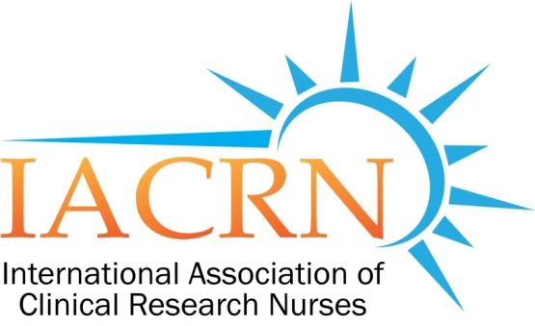
IACRN Research Committee Minutes
October 12, 2016

Cheryl Fisher - Chair | Joy Bailey | Kathy Grinke | Penny Jester
Catherine Griffith - Facilitator | Georgie Cusack | Carolynn Jones | Rosemary Keller
Shaunagh Browning

Presiding: Cheryl Fisher: Chair; meeting called to order 3:36 PM
- Announcements:
  - 8th Annual Conference Countdown – 12 days away!

- Review of September 14, 2016 minutes: Minutes approved as written

- Subcommittee Updates
  - Deviations Study: Penny and Carolynn
    - Study is finished: study exploring differences in deviation rates reported among study staff.
    - Informed consent; endpoints; eligibility; adverse events
    - NIAID (Nat’l Institute of Allergy & Infectious Disease) is the coordinating center (access to monitoring reports).
      - Sites
        - 13 total sites: 7 sites with RN coordinators
        - 6 sites with non RN Coordinators.
        - Did not use sites with mixed personnel. Too challenging to determine which role created the deviation.
      - Methods:
        - 101 total deviations were examined.
        - Used Chi Square: RN vs Non RN rates of reporting deviations
        - 3 out of 4 showed significant differences in favor of RN. IC p<0.01; Adverse events p<0.03; Overall p < 0.001
      - Consulting with Statistician: verify tests used for data analysis.

  - Workforce – Cheryl
    - Follow-up with ISRC reviewer (Allyson Ross) who has experience with large data sets.
    - Questions: What is the N? How are we going to collect the sample?
    - Suggestions:
      - First survey use IACRN membership list to start; compile list of Research Centers
      - Second email: sent to IACRN members who will be asked to forward to non members. This one will be tagged so responses can be tracked. This will provide a mechanism to separate out IACRN characteristics from non-members.
      - 25% return - considered good percentage return rate.
      - Pilot the survey with 10 people.
      - Keep official survey open for 3 weeks.
      - Look at sample of survey and standard language from study on Nurse Coaching.
- Preconference: Nominal Group: Carolynn, Cheryl, Catherine
  - 32 people registered.
  - Attendee information will be sent out to include mission, vision, strategic plan; research question and CDC information on Nominal Group Technique.
  - Facilitator information: Need 5 table facilitators.
    - Script; sequence of activities; facilitator job description.
  - Discussion about how the session will be sequenced.

- Adjourned at 16:40.

Submitted,
Catherine A. Griffith, PhD, RN, Research Committee Facilitator

